Pie tin particles
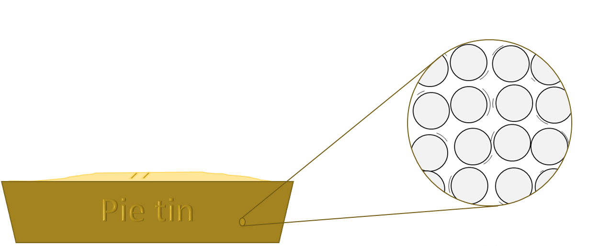
John has just made a fruit pie.
It is ready to go into the oven
The particles in the pie tin are arranged in a regular pattern.
They are vibrating and bumping into each other.

In the oven the pie tin heats up to 180ºC.
What do you think happens to the particles?
For each statement, tick (✓) one column to show what you think.
Statements |  | I am sure this is right | I think this is right | I think this is wrong | I am sure this is wrong
A | They get heavier
B | They get bigger
C | They vibrate more quickly
D | They push into each other with more force
E | They change shape

Physics > Big idea PMA: Matter > Topic PMA1: Heating and cooling > Key concept PMA1.1: Temperature
Diagnostic question
Pie tin particles

Overview
Learning focus: | Temperature is a measure of the average speed at which the particles in a substance or material are moving
Observable learning outcome: | Describe the changes in particles of a substance or material when its temperature is changed
Question type: | Confidence grid
Key words: | Particle, vibrate

What does the research say?
An understanding of what happens to particles when they are heated is necessary in order to explain the mechanisms of heating, and to understand the difference between temperature and a thermal store of energy. Earlier ideas about the arrangement and movement of particles in solids, liquids and gases (BEST key concept: CPS1.1: Particle model for the solid, liquid and gas states) can be used to construct models in order to help develop students’ understanding of these things.
Johnson (1998) found research evidence showed that very few students have an appreciation of the intrinsic motion of particles. Many have difficulties with the idea that there is ‘nothing’ between particles. Others think of particles with the same properties as tiny pieces of the bulk material. This may lead to students thinking that particles expand when they are heated, in the same way that a substance does.
Ways to use this question
Students should complete the confidence grid individually. This could be a pencil and paper exercise, or you could use an electronic ‘voting system’ or mini white boards and the PowerPoint presentation.
If there is a range of answers, you may choose to respond through structured class discussion. Ask one student to explain why they gave the answer they did; ask another student to explain why they agree with them; ask another to explain why they disagree, and so on. This sort of discussion gives students the opportunity to explore their thinking and for you to really understand their learning needs.
Differentiation
You may choose to read the questions to the class, so that everyone can focus on the science. In some situations it may be more appropriate for a teaching assistant to read for one or two students.
Expected answers
Answers C and D are correct: the particles move more quickly and push into each other with more force.
How to respond - what next?
Students who think that answers A, B or E are correct are likely to hold the misunderstanding that particles have the same properties as tiny pieces of the bulk material.
If students have this misunderstandings about particles, it can be helpful to explain and discuss the scientific model (kinetic particle model) with students. Challenging them to use this model to explain phenomena such as expansion can help clarify and consolidate their understanding. It can be particularly fruitful to challenge students to explain why other models fail to explain these things.
The following BEST ‘response activities’ could be used in follow-up to this diagnostic question:
- Response activity: Ouch!
- Response activity: Expansion model
Acknowledgments
Developed by Peter Fairhurst (UYSEG), based on York Science question M2:09
Images: Peter Fairhurst (UYSEG).
References
Johnson, P. (1998). Progression in children's understanding of a 'basic' particle theory: a longitudinal study. International Journal of Science Education, 20(4), 393-412.

